System Architecture: TrackBudget
Project Manager: Mohamed Elgasim
Development Team: Miguel Flores (Backend), Hashim Abdulla (Frontend), Krishna (Database)
Application: TrackBudget Financial Web Application
Architecture Style: 3-Tier Client-Server Model with External API Integration
1. Architectural Overview
TrackBudget utilizes a standard 3-tier architecture comprising a Presentation Layer, an Application Layer and a Data Access Layer. Rather than a decoupled single-page application, the frontend is built using Server-Side Rendering (SSR) using Flask where the backend directly renders and serves HTML templates. The system also integrates an external component to power the AI Financial Assistant using a secure API bridge.
2. System Architecture Diagram
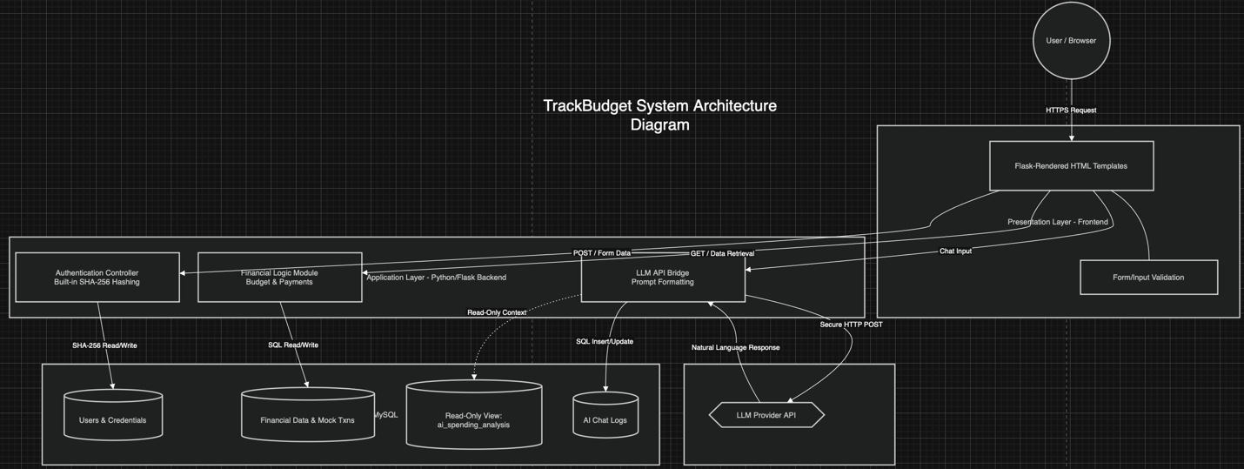
3. Component Descriptions
3.1 Presentation Layer (Frontend)
Managed by Hashim Abdulla, the frontend uses Flask’s built-in template engine to display information.
- Server-Side Rendered Pages: Pages are dynamically generated on the server and sent as complete HTML files to the browser eliminating the need for client-side routing.
- User Interface (UI): Features strict text alignment and negative space for maximum readability following the Commerce Bank's design constraints.
- Client-Side Validation: Validates form inputs before submitting POST requests to the backend.
3.2 Application Layer (Backend)
Managed by Miguel Flores, the Python/Flask backend serves as the core processor of the application.
- Authentication Controller: Receives registration and login requests. It uses Python's built-in SHA-256 hashing to securely generate and verify password hashes against the database.
- Financial Logic Module: Manages mock user data, calculates budget analytics and handles user account updates.
- LLM API Bridge: A dedicated module that handles AI chat queries. It extracts financial context and formats prompts before sending them to the external AI model.
3.3 Data Access Layer (Database)
Managed by Krishna, the MySQL database provides persistent storage and data isolation.
- Users & Credentials Table: Stores SHA-256 hashed passwords, usernames, and unique user IDs.
- ai_spending_analysis (Read-Only View): A dedicated read-only database view created specifically for the AI. This view securely exposes only the necessary transaction trends without giving the AI access to raw underlying tables.
- Chat Logs Table: Stores historical conversations between the user and the AI Assistant.
4. Data Flow & Integration Points
4.1 User Authentication Flow
- Input: The user submits their credentials using the login/registration form/page.
- Transmission: The form triggers a POST request to the Flask server's auth routes.
- Processing: The Auth Controller accepts the input and applies a built-in SHA-256 algorithm to hash the password.
- Validation: The backend compares the generated hash against the one stored in the database.
- Output: Upon a successful match, the Flask server sets up a secure user session and returns a fully rendered Dashboard template to the user's browser.
4.2 Financial Data Retrieval Flow
- Trigger: The user opens the Central Dashboard.
- Server Query: The Flask backend checks the active session, retrieves the user's ID and queries the database for matching transaction data.
- Template Rendering: The backend injects the retrieved data into the Flask HTML template server-side.
- Display: The browser receives and displays a fully formatted webpage.
4.3 AI Assistant Integration Flow
- User Prompt: The user types a question into the chat interface.
- Context Gathering: Instead of querying the general database tables, the Flask backend pulls clean optimized financial data directly from Krishna's dedicated ai_spending_analysis read-only view.
- External Integration: The LLM API Bridge attaches this read-only context to the user's prompt and sends it to the AI model via a secure HTTP POST request.
- Response Handling: The AI processes the request and sends back a natural language response. The backend commits the message to the database chat logs and returns the rendered answer to the user's screen.

